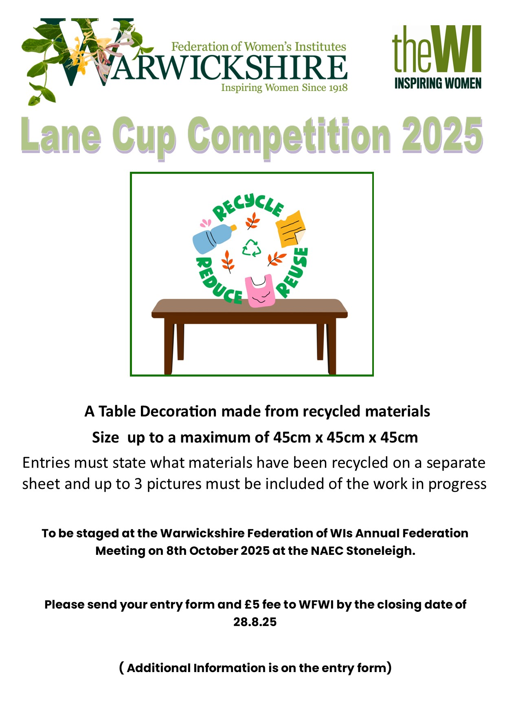
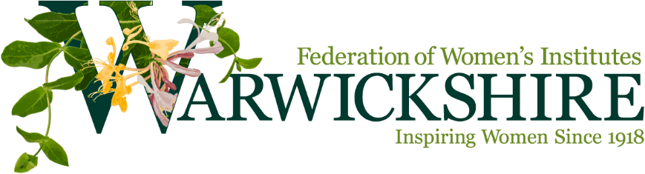

LANE CUP 2025
To be staged at the Warwickshire Federation Annual Federation Meeting on Wednesday 8th October 2025.
SCHEDULE:
A Table Decoration made from recycled materials
Size up to a maximum of 45cm x 45cm x 45cm
Entries must state what materials have been recycled on a separate sheet and up to 3 pictures must be included of the work in progress.

RULES:
1. One entry per WI
2. Must be competitor’s / WI own work
3. Exhibits to be staged at NAEC Stoneleigh 8th October 2025 between 9.00 and 9.30am. No entries will be accepted after this time.
4. Exhibits must be removed at the end of the meeting. The Federation, Creative & Culture Committee will not be responsible for any exhibits left after the meeting.
5. The judges will be appointed by the Creative & Culture Committee. The decision of the judge will be final, and no correspondence will be entered into.
6. Whilst every care will be taken with exhibits, the Federation & the Creative & Culture Committee cannot be held responsible for loss of or damage to exhibits during judging and/or display.
7. Judging will be against the following criteria: the visual impact of the table decoration; The use of space and proportion; Design and colour; Technique and workmanship; The use and variety of recycled materials and Finish and Presentation
8. Fee payable to enter is £5.00 and can be paid out of WI funds.
9. The winner will be awarded the LANE CUP for 12 months.

LANE CUP ENTRY FORM
To be staged at the Warwickshire Federation of WIs AFM on Wed 8th October 2025.
At the NAEC Stoneleigh. Please return this form and payment before 28th August 2025.

YOUR WI NAME, CONTACT NAME AND EMAIL ADDRESS

……………………………………………………………………………………………………………………………………………………………………………………

Entry Fee £5.00
BACS to Warwicks FED WI NO 3 089299 65885710 or Cheque paid to WFWI please use reference 4036.

Please return this form to WFWI, 1 Corunna Court, Warwick, CV34 5HQ by 4036 or email admin@wfwi.co.uk
This is a fund-raising competition.

